THEORY ASSIGNMENT NO.1

[NAME: UMANG RAMTEKE; ROLL.NO: CS6-01]

Que) Formulate 20 problem statements for a given dataset using NumPy and Pandas and Apply NumPy and pandas methods to find the solution for the formulated problem statements.

Ans:- <https://colab.research.google.com/drive/16FeTRsm8d-bkYpq_Gh-vvGDRlRdlVO3k?usp=sharing>

Screenshots are shown below incase link doesn’t work.

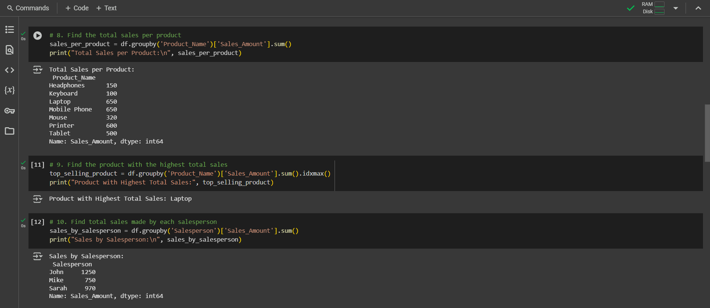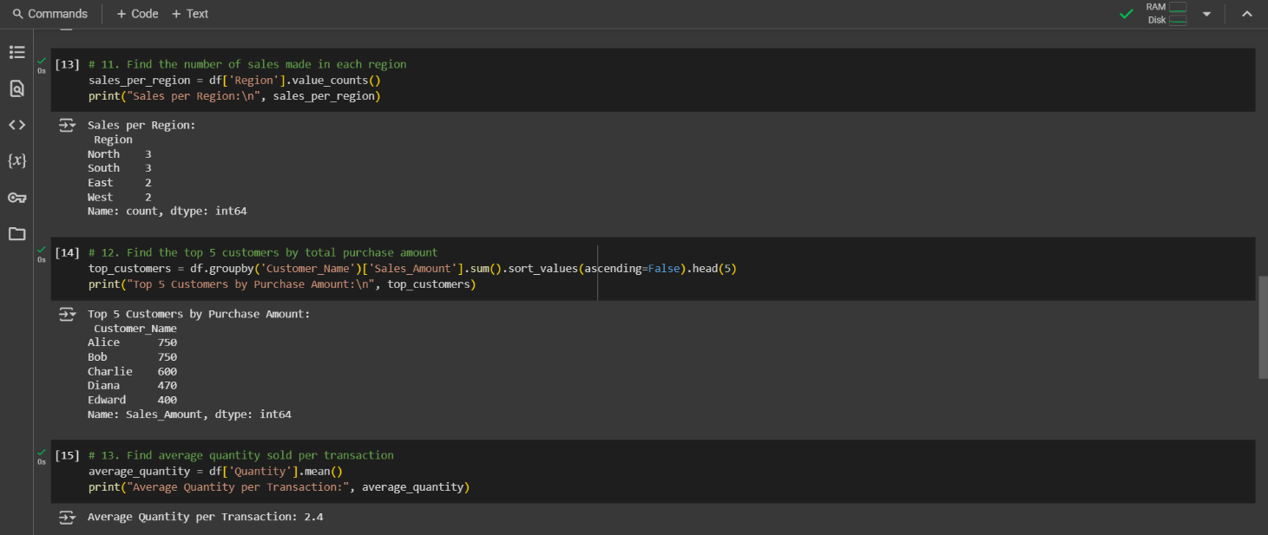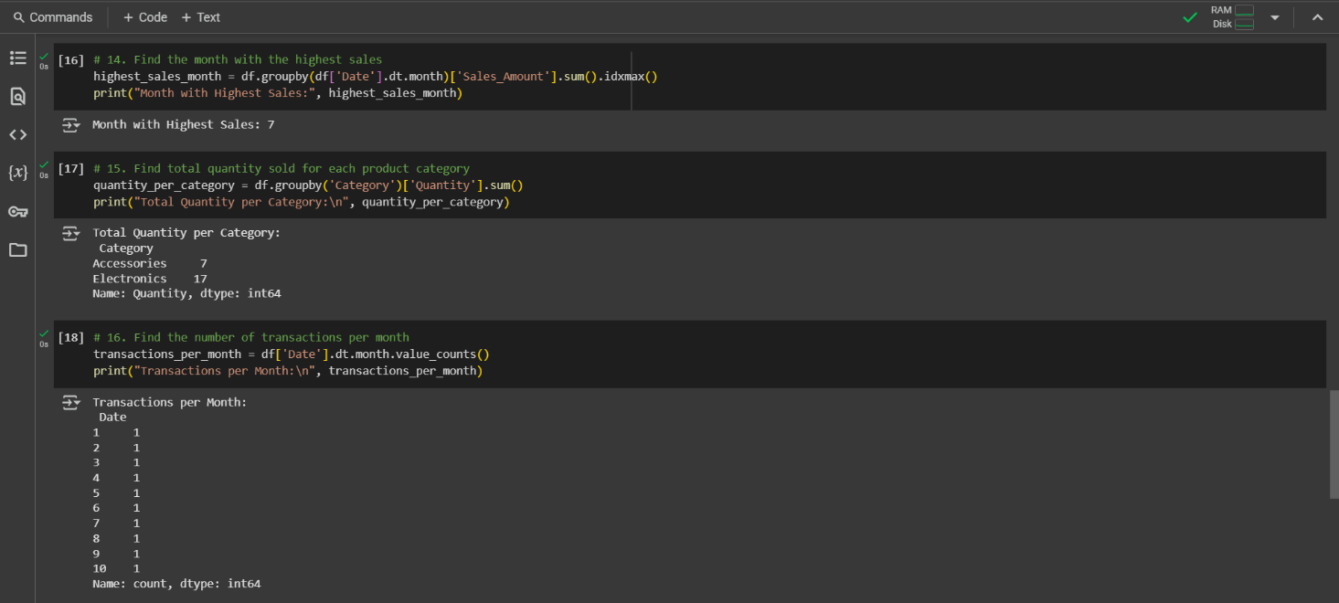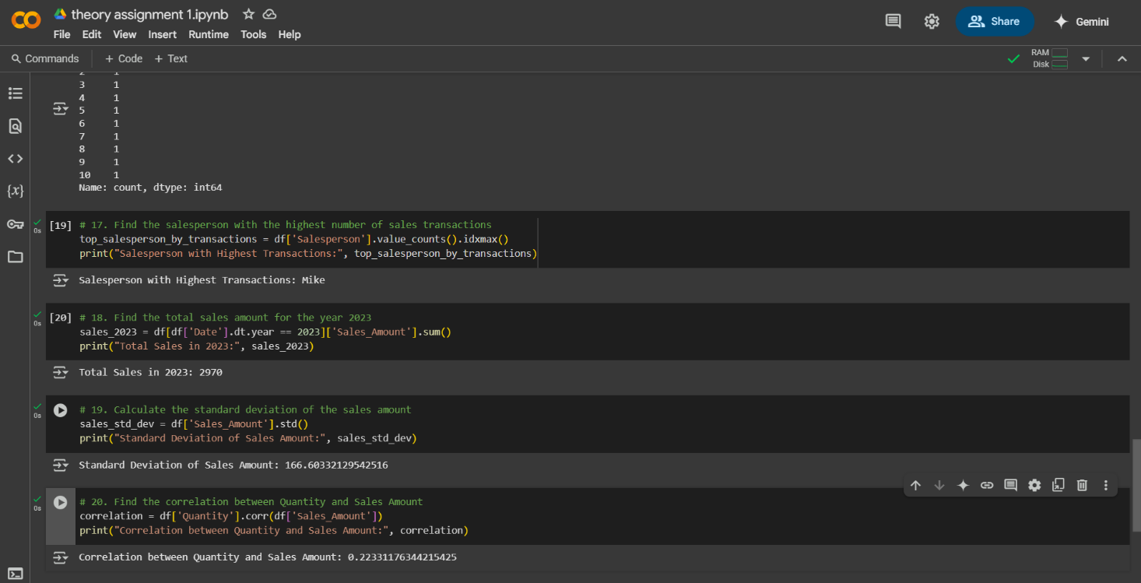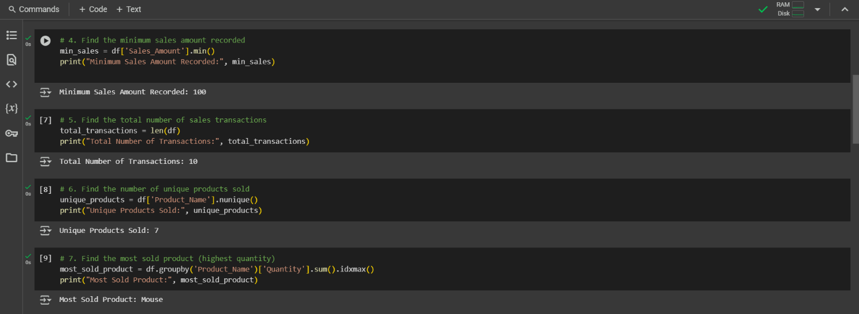 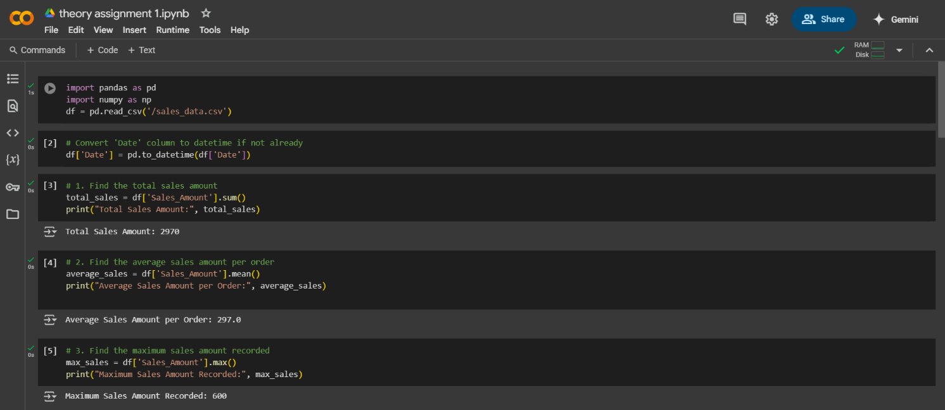

For sample data set used above, use the link given below: [sales_data.xlsx](https://1drv.ms/x/c/8cfd789341475790/EQ-oAyTg3_1CuUT6abh7fvIBUlHThN5LsVHIEcgMo2mRVA?e=thMUS9)

In case file not opend, I have attached screenshot of datatable.

